Sue Bird
WNBA Professional Basketball Player

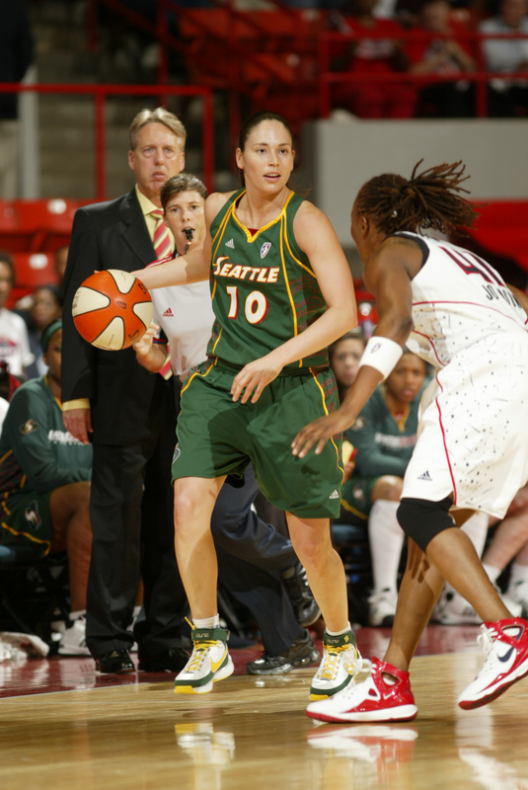
Suzanne Brigit Bird was born in suburban Long Island on October 16, 1980. Her mother, Nancy, was a high school nurse, and her father, Herschel, a cardiologist. She has one sister, Jennifer. Everyone called Sue “Peanut” when she was a kid. She was always happy and energetic—unless she lost at a game, even something as ordinary as Candyland. Then her mood would turn dark, and she would become unapproachable.

Sue’s earliest basketball memory was a trip to see the Chicago Bulls and New York Knicks play in Madison Square Garden in 1988. She recalls a dunk by Michael Jordan, but not much else. A pro hoops career was about the farthest thing from her mind at the time.

Sports was a big part of growing up in Syosset, and Sue was one of those kids instantly better than her classmates at almost every activity she tried. Her best sports were soccer, tennis, track and basketball. A combination of great coordination and an unquenchable thirst for victory propelled her throughout her childhood.

While serious about honing her basketball skills, Sue was hardly a gym rat. When practice was over, she put down the ball and put her mind to other things. More than anything, she enjoyed the social aspect of sports.

Sue was the type of player you noticed immediately. Everything about her was natural and fluid, and she never made the same mistake twice. Once, after her CYO team scrimmaged during halftime at a St. John’s women’s basketball game, the 11-year-old was stopped by a security guard…for her autograph.

That was the same year Sue began showing signs of becoming an elite player. Her father remembers a game in Staten Island to determine who would advance to a national tournament. Sue took over in such convincing fashion that everyone on hand told Herschel his daughter would be a star.

Living in soccer-crazed Long Island, Sue also matured into an avid player on the pitch. The sport helped her develop quick footwork and great anticipation. She found these skills translated well to the hardwood. By age 15, after two years on Syosset's varsity hoops team, her game was ready to blossom. In search of top-level competition for their daughter Sue’s parents enrolled her at Christ the King Regional High School.

With the Royals, Sue stepped directly into the starting point guard job and came into her own. In turn, Christ the King built on its reputation as a national powerhouse. In Sue's junior season, the team went 27-0. She had so many good teammates that instead of shooting, she preferred to set them up. Sue noticed how much better they played when she anticipated their moves and put the ball in their hands at just the right time. This talent became her trademark throughout high school.

Sue’s grades were good enough to get her in to just about any school. With scholarship offers from around the country, she chose the University of Connecticut. She liked the fact that UConn was close to home, but was also drawn to the school because coach Geno Auriemma had fashioned a winning tradition that felt like the one at Christ the King.

Upon settling on UConn, Sue was delighted to learn that she was part of the top recruiting class in the country—some called it the best of all time. This meant that the Huskies would have a strong squad right through her senior year.

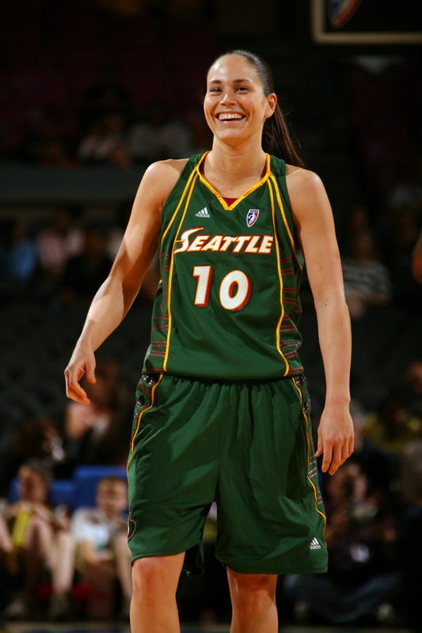
Eight games into the 1998-99 campaign, disaster struck. On a simple stop-and-pop Sue had executed without incident countless thousands of times before, she felt her left knee collapse during practice and had to be carried off the court. Doctors gave her the bad news: it was a torn ACL. She had to sit on the bench the rest of the year, and because she had participated in 20% of the team’s games, she could not red-shirt and come back as a freshman the following fall.

While her fellow Huskies were going full-tilt on the court, Sue had to be satisfied with going full-tilt in rehab. The experience gave her new perspective. Life without basketball made her see the beauty of the game and understand how much it meant to her. She vowed from then on to play every game as if it were her last. Once rehabilitated, Sue was sensational in 2001-02, winning the Wade Trophy, the Naismith Award as College Player of the Year and making the Dean’s list.

As soon as she graduated, Sue began to get offers for commercial endorsements. She signed a three-year deal with Nike and became a spokesperson for American Express. She fielded inquiries from soft drink, automotive, cosmetics and cellular communications companies, too. Also on Sue’s agenda was the WNBA draft, where she would likely be the top selection. She was drafted by the Seattle Storm.

On the court, Sue had to get over her own case of hero-worship. Although she was clearly one of the league’s most talented players, she was in awe of the strength and experience of WNBA veterans. But in no time she accelerated her game, and picked up the entire team. With Jackson on the bench with a bad ankle to start the year, Sue took over and led the Storm to three wins after dropping their opener. In the standings, Seattle began to establish itself as a real contender in the West. To no one's surprise, she was voted to the West starting squad for the 2002 WNBA All-Star Game and in 2004 led her team to a WNBA Championship.

Also in 2004, Sue was slated to suit up for the U.S. women in the Olympics. In the Olympics, Sue was not as much of a factor as she was with the Storm. This was due, at least in part, to the quality of her U.S. teammates. Veteran players like Dawn Staley, Sheryl Swoopes and Lisa Leslie helped lead the way for the women. The U.S. women won every game except one by double digits, and cruised to a perfect 8-0 record in the Olympics.

Few female athletes are better at their sport or more popular than Bird, one of the most decorated women's basketball players in history.

Selection from- http://jockbio.com/Bios/Bird/Bird_bio.html

